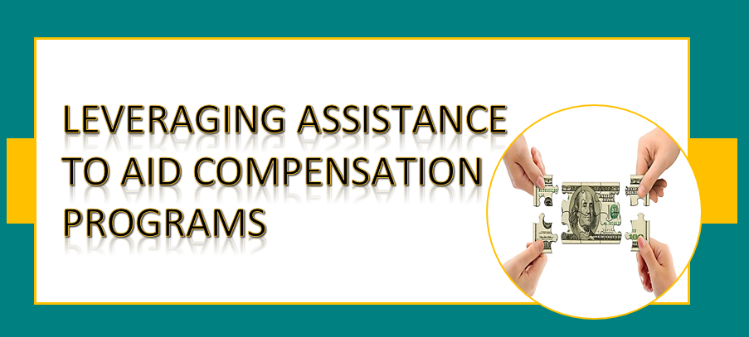

**Winter Webinar Series**

**$ Money, Money, Money $**

***Michelle Crum, Chief***

***Florida Bureau of Victim Compensation***

**DISPROPORTIONATE FUNDING**

In FFY 2017-18, payments to crime victims and operating expenses started to exceed the amount of funding collected. The deficit was exacerbated by trending decriminalization and criminal justice reform causing fewer fines, fees, and judgments for restitution.

Escalated by the availability of funds from the Congressional allocation for Assistance in FFY 2015-16, and Florida launching a web portal in 2017, more money than ever was going to support victim advocacy programs at the same time compensation became easier to access.

In September 2019, the CCTF reached a critical low point, and payment limitations were reduced retroactively. Compensation was reduced by 50% for most benefits, and relocation was reduced by 30%.

Despite an infusion of general revenue, a focused campaign to enforce collections, freezing position vacancies, downsizing staff and cutting benefits, the ability to process payments to victims significantly diminished.

**FORENSIC EXAMINATION VOCA ASSISTANCE SOLUTION**

The Department of Justice (DOJ) published federal guidelines in 2016, that allowed greater flexibility to support forensic evidence collection examinations. Title 28, Code of Federal Regulations, s. 94.119 (g) says, *“Direct services for which VOCA funds may be used include, but are not limited to… Forensic medical evidence collection examinations – Forensic medical evidence collection examinations for victims to the extent that other funding sources such as State appropriations are insufficient.”*

OVC’s Legal Counsel granted acceptance for Florida to establish an annual cap (threshold). Once exhausted, an Assistance grant will reimburse the CCTF.

**RELOCATION VOCA ASSISTANCE SOLUTION**

DOJ Title 28, Code of Federal Regulations, s. 94.119 (l), says “*Relocation - Subject to any restrictions on amount, length of time, and eligible crimes, set by the SAA, relocation of victims, including, but not limited to, reasonable moving expenses, security deposits on housing, rental expenses, and utility startup costs.”*

During FFY 2018-19, 78.3% of all relocation awards compensated were for interim shelter and housing. This proves that housing/safe shelter is the highest demand for victims seeking safety. Housing is also the single largest cost for relocating.

Effective March 1st, 2021, Florida’s Compensation and Assistance programs will move forward with a plan to bifurcate relocation expenses which will improve services and sustainability. Pending legislative budget approval, Assistance will reimburse domestic violence and rape crisis centers for ancillary costs associated with relocating, through their existing VOCA grants. Compensation will address interim shelter and housing costs only.